  Starry Projector Lights

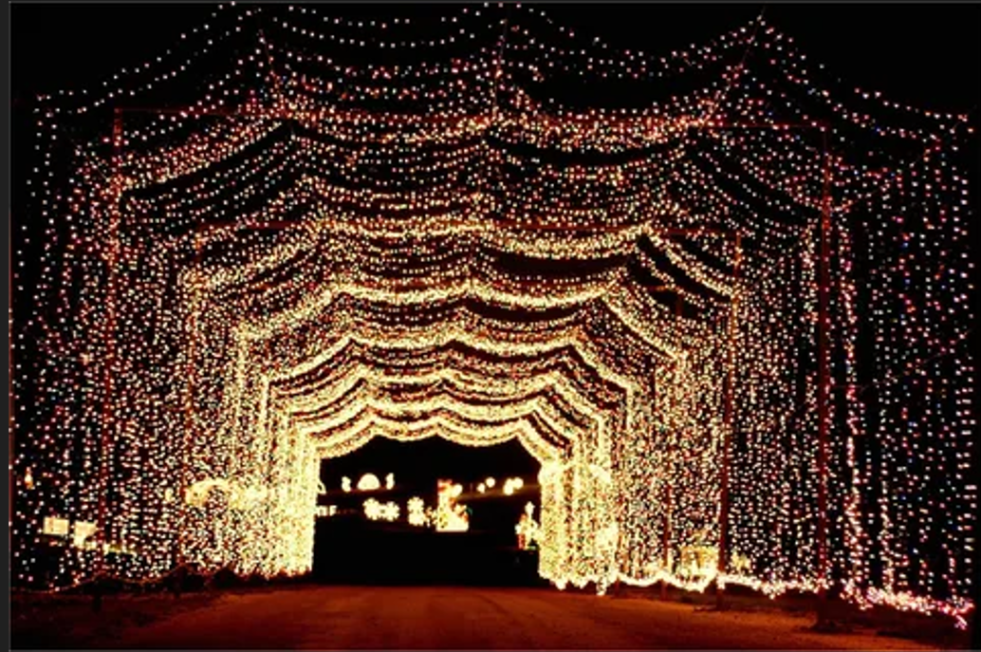

#### ****Description:****

**Starry Projector Lights** are enchanting lighting solutions designed to create a magical starry sky effect in any room. These lights are perfect for creating a relaxing and dreamy ambiance in bedrooms, living rooms, and kids' rooms. With multiple color options and projection patterns, Starry Projector Lights offer a unique and immersive lighting experience.

* **Technology:** LED.
* **Power Source:** Plug-in or battery-operated (depending on the model).
* **Bulb Type:** Integrated LED (non-replaceable).
* **Wattage:** 5W (plug-in), 3W (battery-operated).
* **Lumens:** 50 lumens.
* **Color Options:** Multicolor, blue, green, red.
* **Dimmable:** No.
* **Lifespan:** 20,000 hours.
* **Energy Efficiency:** Energy-efficient LED technology.
* **Projection Patterns:** Stars, galaxies, and other celestial patterns.

#### ****Key Features:****

* **Magical Ambiance:** Creates a starry sky effect for a relaxing and dreamy atmosphere.
* **Energy-Efficient:** Uses LED technology for long-lasting and energy-saving performance.
* **Multiple Colors:** Available in multicolor and single-color options for customizable lighting.
* **Versatile Use:** Suitable for bedrooms, living rooms, kids' rooms, and parties.
* **Easy to Use:** Simple controls for changing colors and patterns.
* **Portable:** Compact and lightweight design for easy placement and portability.

#### ****Pricing:****

* **Single Starry Projector Light (Plug-In):** $29.99
* **Single Starry Projector Light (Battery-Operated):** $34.99
* **2-Pack Starry Projector Lights (Plug-In):** 49.99(49.99(25.00 per light)
* **2-Pack Starry Projector Lights (Battery-Operated):** 59.99(59.99(30.00 per light)

#### ****Where to Use:****

* **Bedrooms:** Create a relaxing and dreamy ambiance for sleep and relaxation.
* **Living Rooms:** Enhance the atmosphere for movie nights and gatherings.
* **Kids' Rooms:** Provide a fun and magical lighting experience for children.
* **Parties:** Add a unique and festive touch to indoor celebrations.
* **Meditation Spaces:** Create a calming environment for meditation and yoga.

### ****Customer Reviews:****

* ⭐⭐⭐⭐⭐ "These Starry Projector Lights are amazing! They create a magical starry sky effect in my bedroom, perfect for relaxing and unwinding." – Sarah L.
* ⭐⭐⭐⭐ "Great value for the price. The lights are bright, and the multiple color options add a fun touch to any room." – James T.
* ⭐⭐⭐⭐⭐ "I love how energy-efficient these lights are. The projection patterns are beautiful and create a calming atmosphere." – Emily R.

### ****How to Order:****

1. Visit our website: [www.brightworldlighting.com](http://www.brightworldlighting.com/)
2. Select your preferred power source (Plug-In or Battery-Operated) and pack size (Single or 2-Pack).
3. Add to cart and proceed to checkout.
4. Enjoy free shipping on all orders over $50!

### ****Warranty and Support:****

* **Warranty:** 1-year limited warranty covering manufacturing defects.
* **Customer Support:** Contact us at [support@brightworldlighting.com](mailto:support@brightworldlighting.com) or call +1-800-123-4567 for assistance.

### ****Visual Representation:****

Include high-quality images of the Starry Projector Lights in different settings (e.g., bedrooms, kids' rooms) to showcase their versatility and design.